**TRƯỜNG ĐẠI HỌC PHENIKAA**

**KHOA CÔNG NGHỆ THÔNG TIN**

**BÁO CÁO QUẢN TRỊ DỰ ÁN CHO CÔNG NGHỆ THÔNG TIN**

***Nhóm 6  
Capstone Project Scenario Real-Time Market Insights App***

***Nguyễn Chí Công             20010846*** [***20010846@st.phenikaa-uni.edu.vn***](mailto:20010846@st.phenikaa-uni.edu.vn)

***Nguyễn Vũ Tuấn Hùng   20010901*** [***20010901@st.phenikaa-uni.edu.vn***](mailto:20010901@st.phenikaa-uni.edu.vn)

***Nguyễn Văn Cường         20010888***[***20010888@st.phenikaa-uni.edu.vn***](mailto:20010888@st.phenikaa-uni.edu.vn)

***Nguyễn Văn Tuyền          20010881***[***20010881@st.phenikaa-uni.edu.vn***](mailto:20010881@st.phenikaa-uni.edu.vn)

***Giáo viên hướng dẫn: TS Mai Xuân Tráng***

**HÀ NỘI, Tháng 03 năm 2024**

**1 Project Charter**

**Instructions:** Fill in the fields of this project charter with the information provided in the lab scenario. Click into the column and begin typing to enter information.

|  |  |
| --- | --- |
| **Charter Item** | **Comments** |
| Project Name | Real-Time Market Insights App |
| Project Goal | Develop and deploy an application to provide real-time market information and analysis to Acme Health Innovations (AHI) |
| Project Value Proposition and Benefits | * Enable faster introduction of new and updated products to the target market * Improve the overall AHI customer experience * Enable better positioning to be worked out through analysis of individual product sales * Enable better business decisions * Accelerate the testing of new product concepts * Gain insights into current shoppers and demographics   Enable improved brand tracking |
| Problem or Opportunity Statement | * Acme Health Innovations (AHI) currently relies on disconnected systems for marketing analytics, hindering its ability to adapt to a rapidly changing market environment. * AHI has an opportunity to enhance its market competitiveness and improve operational efficiency by developing a real-time market insights app. This app will integrate data from various sources to provide comprehensive analytics on customer preferences, market trends, and competitor insights. |
| Project Schedule | * Analyze opportunities * Select target market * Segment the market * Determine market strategies   Evaluate results and realign |
| Project Manager | Cary Manning |
| Approval  Authority/Sponsor | Mary Smithers |
| Assumptions or Constraints | Assumptions:   * Assume availability of necessary data feeds for real-time market analysis. * Assume cooperation and participation from stakeholders throughout the project lifecycle. * Assume the initial cost estimates are accurate and sufficient to cover project expenses.   Constraints:   * Budget constraints may limit the scope of the project and resource allocation. * Time constraints may impact the development and implementation timeline. * Dependence on existing IT infrastructure and resources may impose limitations on scalability and functionality. |
| Proposed Solution(s) | * Develop a real-time market insights app integrating data analytics * Implement features for (facilitate easier customer access to AHI products and pricing) and (enable secure invoicing and order processing) for external customers * Enhance capabilities for (monitor customer interest and preferences for AHI products based on opinion analysis) and (generate competitive analysis data by analyzing global sales data) |
| Project Priorities | 1. Schedule: Must be completed by the 1st of October 2024 2. Budget: $300,000 3. Scope: Flexible, development of key app functionalities outlined in the business case |
| Return on Investment (ROI) | * Cost: $300,000 * Projected Revenue: $500,000 annually * Return on Investment (ROI): ($500,000 - $300,000) / $300,000 = 0.67 or 67% |
| Risks  (Potential) | * Technical challenges * Data security breaches * Stakeholder resistance * Market volatility * Budget overruns * Integration issues * Regulatory compliance * User adoption * Scalability constraints * Dependency on third-party providers |
| Resources Required | * Development Team * IT Infrastructure * Data Feeds * App Security Measures * Training * Project Management * Financial Resources * Stakeholder Engagement * Marketing Support * Ongoing Support |

* 1. Project Brief

**Instructions:** Fill in the fields of this project brief with the information provided in the lab scenario. Click into the column and begin typing to enter information.

|  |  |
| --- | --- |
| **Project Details** | **Project Brief** |
| Project Name | Real-Time Market Insights App |
| Project Manager | Cary Manning |
| Project Purpose | Develop and deploy an application to provide real-time market information and analysis to Acme Health Innovations (AHI) |
| Project Benefits | * Enable faster introduction of new and updated products to the target market * Improve the overall AHI customer experience * Enable better positioning to be worked out through analysis of individual product sales * Enable better business decisions * Accelerate the testing of new product concepts * Gain insights into current shoppers and demographics * Enable improved brand tracking |
| Project Schedule | * Analyze opportunities * Select target market * Segment the market * Determine market strategies * Evaluate results and realign |
| Project Costs | $250,000 |
| Project Sponsor | Mary Smithers |

* 1. **Develop Stakeholder Register**

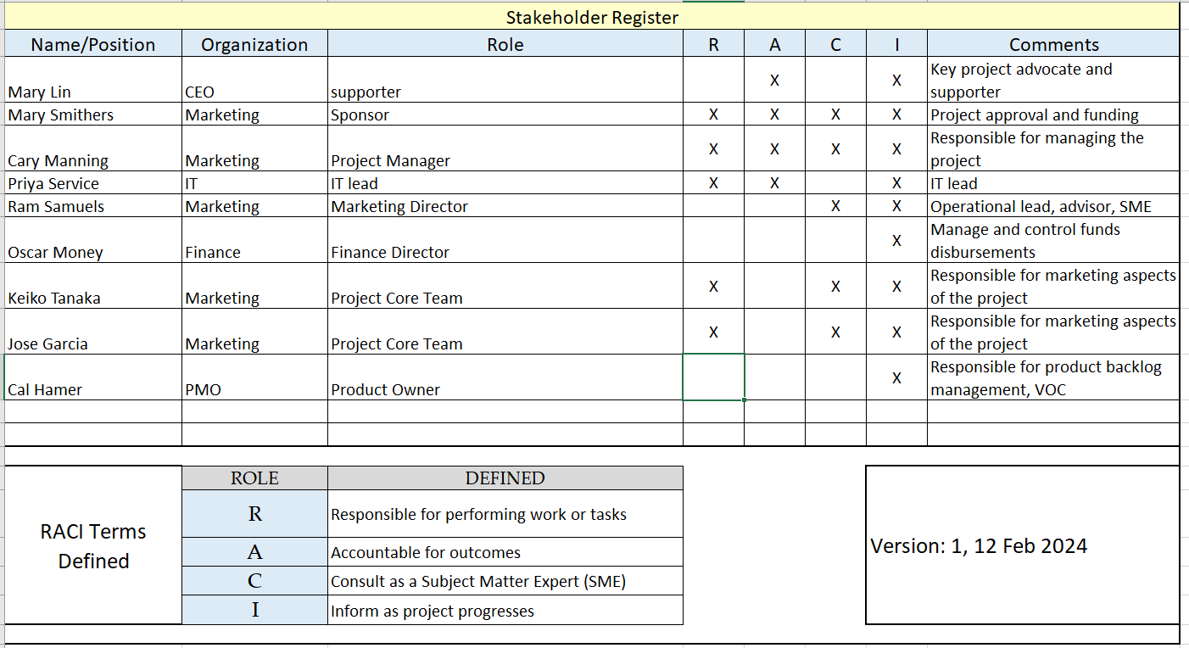

1. **Work Bearkdown Structure**

**2.1 High Level Budget**

**2.2 Project Network Diagram**

1. **Risk Register**

1. **Product Backlog**

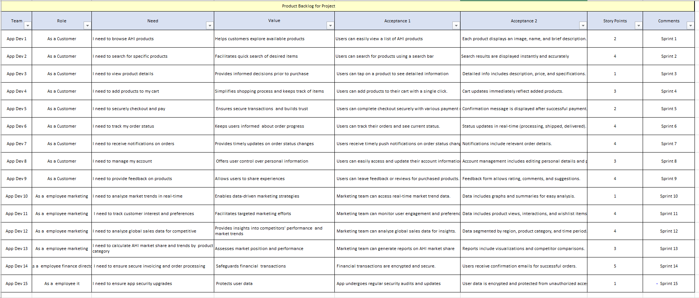

**4.1 Sprint Backlog**

**4.2 User Story**

**5. Statistics and Brundown Chart and Karban Board**

The AHI development team is working to complete all app development deliverables supporting the project. They are using the Scrum methodology.

The team plans to complete development in two Sprints. (Note: Sprint Backlog Lab Solution reference). It identified five user stories, estimated at 20 story points. The team assumed it could complete 10 story points in each Sprint. It budgeted 165 hours for Sprint 1 and 170 hours for Sprint 2. The team estimated 335 hours as the total time for the entire app development and scheduled each Sprint to last 30 days.

The team is new, and the members do not know each other. The group consists of two internal developers and one external development consultant. Cal Hamer is the product owner. Cal understands the needs of the customers well. However, he is new to the Product Owner position. AHI does not have a Scrum Master to support app development. Cary Manning is the designated Scrum Master. Cary is well-versed in predictive project management methods. However, he has no experience in Scrum.

The Sprint 1 User Story was 0004, developed to ensure that all IT hardware, software, and interfaces were installed to support the new app. Cary worked with the team to create an updated Sprint Backlog. He assigned tasks to team members and held a daily one-hour meeting to discuss status. He also developed a change form to manage changes. The team initially developed an IT infrastructure to support 500 internal and 20 million external app users.

User story 0002 dealt with marketing support requirements. After the Sprint began, Cal worked with marketing staff and updated the user story to reflect the new needs. Cal scheduled a meeting with marketing and the team to discuss the changes.

The first demo for Sprint 1 surprised the stakeholders. They informed the team that the app should support 200 internal and four million external users. That notice came too late. IT invested in more infrastructure than the app realistically needed. Cary determined that issues were impacting the budget and schedule for the app development and used the Sprint 1 retrospective as a forum for a comprehensive root-cause analysis and development of solutions to support Sprint 2.

The team is now in Sprint 2. It encountered issues on user story 0001 and completed only 20 of the planned 40 hours. Some key executives added reporting requirements not included in the original user story.

The team reviewed the project network diagram and found that the total development cycle for the app was 90 days. Cal realized that the five planned user stories in the product backlog did not include updating the original app prototype and developing an initial launch plan. AHI leadership approved the network diagram and a 90-day development cycle. The current roadmap calls for two 60-day Sprints.

Cary and Cal worked together to create a burndown chart for the entire app development phase of the project. Here is the current version:

Image Brundown Chart

Burndown Chart Analysis Worksheet

**Instructions:**

Use this worksheet to perform and document your analysis of the AHI app development project.

List **at least three** observations for each question.

Question 1: What problems does the burndown chart show about the project?

|  |
| --- |
| 1. Slow Progress: The burndown chart shows a relatively flat slope, indicating that the team is not burning down tasks at the expected rate. This suggests that progress is slower than anticipated, which could lead to delays in completing the project within the planned timeframe. |
| 1. Incomplete Scope: The chart also indicates that the team has not yet completed a significant portion of the planned work, as the remaining work (the gap between the ideal line and the actual line) is substantial. This suggests that there may be issues with accurately estimating the scope of the project or with the team's ability to deliver on time. |
| 1. Scope Creep: There are fluctuations in the actual line, indicating that additional work is being added to the project beyond what was originally planned. This could be indicative of scope creep, where new requirements or changes are introduced without proper assessment of their impact on schedule and resources. |

Question 2: What changes could the team make to improve the chances of meeting the project scope and schedule?

|  |
| --- |
| 1. Scope Refinement: The team should revisit the project scope and refine it to ensure it is well-defined and manageable within the given timeframe. This may involve prioritizing features and functionalities to focus on delivering the minimum viable product (MVP) within the current timeline. |
| 1. Stakeholder Communication: Improve communication with stakeholders, particularly regarding changes in requirements or expectations. This includes setting clear boundaries for scope changes and ensuring that all stakeholders understand the implications of such changes on schedule and resources. |
| 1. Agile Training: Provide training and support to team members, including the Product Owner and Scrum Master, to enhance their understanding and implementation of Agile principles and practices. This can help improve estimation accuracy, identify and address issues early, and foster better collaboration within the team. |

Question 3: What changes could the team have made earlier to be more successful?

|  |
| --- |
| 1. Comprehensive Sprint Planning: Invest more time and effort in Sprint planning to ensure that all tasks are well-defined, estimated accurately, and aligned with the project objectives. This includes involving all relevant stakeholders to gather requirements and prioritize tasks effectively. |
| 1. Continuous Feedback: Establish mechanisms for gathering feedback from stakeholders throughout the project lifecycle to identify any emerging issues or changes in requirements early on. This can help mitigate the risk of last-minute scope changes and ensure alignment with stakeholders' expectations. |
| 1. Risk Management: Implement a proactive risk management approach to identify and mitigate potential risks that could impact project scope, schedule, or quality. This involves conducting thorough risk assessments, developing mitigation strategies, and regularly monitoring and reassessing risks throughout the project. |

Kanban Board

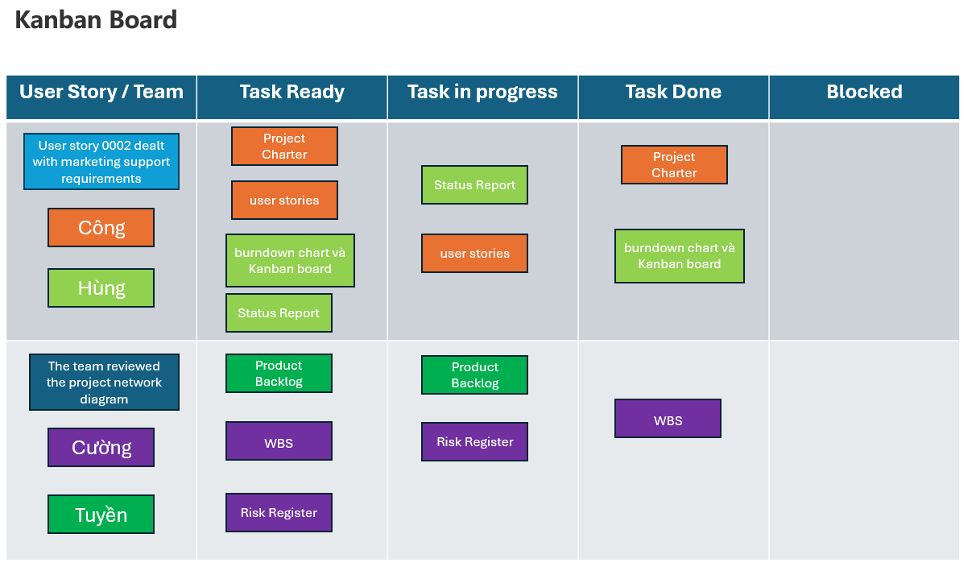

In this Kanban Board:

* Column one lists the user story by identifier and the team members who will accomplish the tasks. It is common for each team member to choose a distinct color for the jobs they are completing.
* Column two lists tasks ready for development by the team.
* Column three lists tasks in progress. Some teams apply "Work in Progress (WIP)" limits to manage workload to ensure the team is not trying to accomplish too many tasks simultaneously. WIP limits indicates limited resources or capacity.
* Column four lists tasks "Done." Recall the definition of "Done." Done indicates completed user acceptance criteria according to customer satisfaction.
* Column five shows tasks that are blocked. The Scrum Master asks each team member if there are any blockers at the daily Scrum meeting. Kanban board A displays blocked tasks. The Scrum Master addresses blocked tasks as soon as possible to ensure the Sprint can progress.

**5 - Change Request**

|  |  |  |  |  |
| --- | --- | --- | --- | --- |
| **Project:** | | *AHI App Development* | **Change ID:** | *0002* |
| **Date Requested:** | | *01/03/2024* | **Requested By:** | *Dev AHI* |
| **PM:** | | *Cary Manning* | **Requestor Email:** | *Dev@AHI.net* |
|  | |  |  |  |
| **Decision:** | | *Pending* | **Decision Date:** | *27/03/ 2024* |
|  | | Accepted, Accepted with Modifications, Rejected, Deferred,  Further Analysis Required |  |  |
| **Proposed Change:** Detailed description. Focus on business needs, requirements; solution is secondary. | | | |
| Two additional data feed sources have been identified. Request these data feeds be incorporated as inputs to the App. Preliminary review indicates these data feeds will add $2500 to the project cost. Time to gain licensing and activation is estimated at two weeks. | | | |

|  |
| --- |
| **Reason for Change:** Focus on benefits that will accrue after the change is made. Describe why this change was not addressed earlier in the project. Who or what is driving this change? |
| The first data feed will provide advanced global sales data in the skin care product industry. In addition, updates are made weekly.  The second data feed will provide better demographic analytics to segment and position our products effectively. |

|  |
| --- |
| **Impact Analysis:** Consider impact on work products, quality, schedule, scope, budget, people, resources, and other projects. List cost/benefit/ROI. Consider impacts on all groups and stakeholders. List assumptions, dependencies, and risks. Define approval levels. |
| *Work Products: The incorporation of additional data feeds will enrich the App's analytical capabilities, resulting in more robust market intelligence reports and targeted product strategies.*  *Quality: The availability of advanced sales data and demographic analytics will enhance the accuracy and relevance of the App's insights, ultimately improving overall quality.*  *Schedule: Integrating the new data feeds may lead to a slight delay in project delivery, with an estimated two-week timeframe for licensing and activation.*  *Scope: The project scope will expand to accommodate the integration of the additional data feeds, aligning with the business's evolving requirements.*  *Budget: The projected cost increase of $2500 will need to be factored into the project budget.*  *People/Resources: The implementation of this change may require additional resources for data integration and testing.*  *Other Projects: The decision to prioritize this change may impact the resource allocation and priorities of other concurrent projects.*  *Assumptions, Dependencies, Risks: Assumptions include the availability of necessary licenses for the data feeds and the compatibility of existing systems with the integration process. Dependencies may include cooperation from third-party data providers and timely approvals. Risks include potential data inaccuracies and technical challenges during integration.*  *Approval Levels: Approval for this change may involve stakeholders such as project sponsors, relevant department heads, and legal/financial representatives.* |

|  |
| --- |
| **Implementation Options:** Consider options to implement this change. What strategies are recommended? How will implementation impact current scope, budget, and schedule milestones? |
| *Several implementation options can be considered:*   1. *Direct Integration: Incorporate the new data feeds directly into the existing App architecture, ensuring seamless compatibility and functionality.* 2. *API Integration: Utilize APIs provided by the data feed sources to integrate the data into the App, minimizing development efforts and streamlining updates.* 3. *Third-Party Solutions: Evaluate third-party solutions or platforms that specialize in data aggregation and analytics, potentially offering comprehensive features and support.*   *The chosen implementation strategy should be assessed based on its alignment with project objectives, impact on current scope, budget implications, and adherence to schedule milestones. Close coordination with development teams and stakeholders will be essential to ensure smooth integration and minimal disruption to project timelines.* |

|  |  |
| --- | --- |
| **Close-Out Checklist (As Applicable):** | |
|  | Change Logged in Change Log (all changes, regardless of decision, must be recorded) and Posted on Project Site |
|  | Scope Document and other Key Project Documentation Updated |
|  | Design document, test plan, test cases, training notes, and others updated |
|  | Schedule and budget updated |
|  | Status Report Updated |
|  | Change Communicated to Stakeholders |

6 - Project Status Report

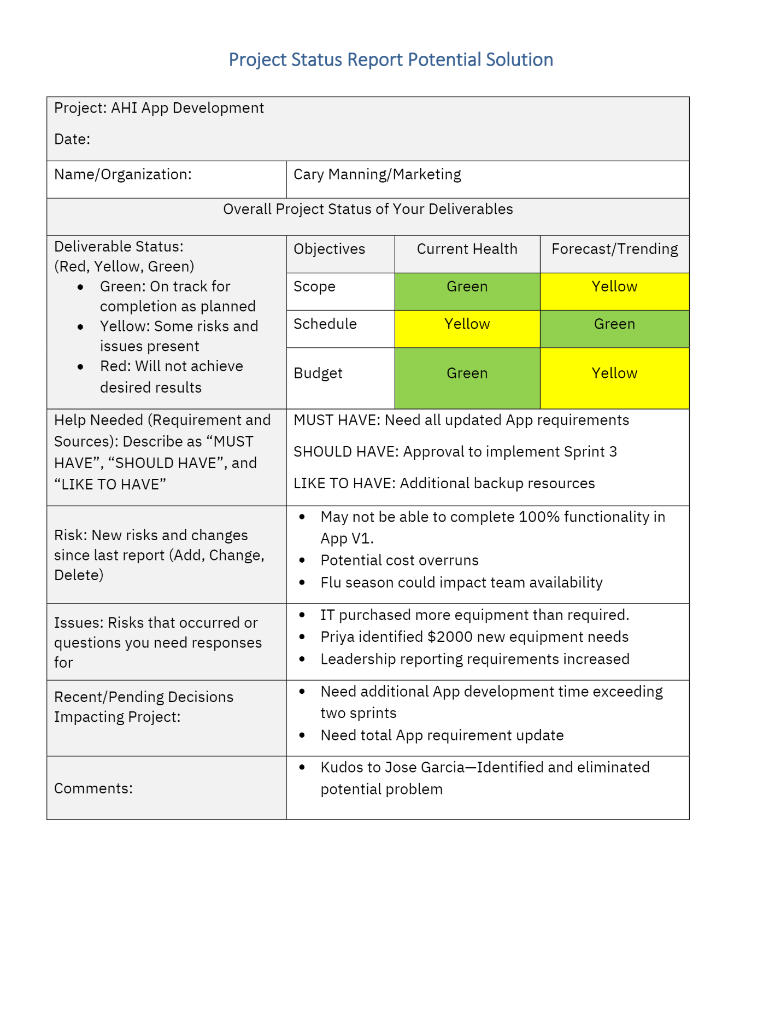

7 - Project Close-Out Report

|  |  |
| --- | --- |
| Project Close-Out Report | |
| **Report Date: 27/03/2024** | |
| **Key Information** | |
| Project Name | *AHI App Development (Acme Health Innovations)* |
| Division/Department | Team_6_PNK |
| Project Sponsor | Phenikaa University |
| Project Manager | Cary Manning |

|  |
| --- |
| **Project Goals** |
| Document the original goals from the project charter. |
| 1. A major provider of advanced skin care products |
| 1. develop an application (app) that provides real-time marketing data to address marketing shortfalls |
| 1. Improve customer satisfaction |
| 1. Establish marketing strategies |
| 1. Achieve financial targets |

|  |
| --- |
| **Project Goal Success Analysis** |
| Highlight the success or failure in meeting the project goals from the original plan and explain deviations. (Success, Partial Success, Not Accomplished) |
| 1. The primary goal of this project is to research, design, and develop advanced skin care products that will provide significant benefits to our customers.  2. The project aims to meet the evolving needs of our customers by offering high-quality, effective skin care solutions that address various skin concerns.  3. Develop comprehensive marketing strategies to effectively promote and distribute the new skin care products, ensuring maximum market penetration and customer reach.  4. The project aims to generate a positive return on investment by successfully launching and selling the developed skin care products. |

|  |
| --- |
| **Scope Review** |
| Call out any variances to the original scope plan and briefly describe why they happened. Can these variances be prevented in future projects? If so, how? |
| Product Range Expansion:   1. Variance: The original scope plan outlined the development of a specific set of skin care products. However, during the project execution, additional product variants were introduced to cater to diverse customer needs. 2. Reason: Customer feedback, market research, and emerging trends necessitated the expansion of the product range to address a broader range of skin concerns and preferences.   Extended Regulatory Compliance Activities:   1. Variance: The timeline for regulatory compliance activities extended beyond the initially estimated duration. 2. Reason: Stringent regulatory requirements, unexpected regulatory changes, and delays in obtaining approvals contributed to the extension of compliance activities.   Production Process Optimization Challenges:   1. Variance: Challenges arose during the optimization of production processes, leading to delays in achieving desired efficiency targets. 2. Reason: Complexities in integrating new technologies, training personnel, and addressing unforeseen technical issues prolonged the optimization process.   Scope Expansion Due to Stakeholder Input:   1. Variance: Scope expanded to accommodate additional features and requirements based on stakeholder input received during the project execution. 2. Reason: Stakeholders provided valuable insights and suggestions that were deemed essential for enhancing product effectiveness and market competitiveness.   Market Strategy Adjustments:   1. Variance: Adjustments were made to the original marketing strategies based on market dynamics and competitor actions. 2. Reason: Market conditions, consumer behavior, and competitor activities evolved during the project timeline, necessitating agile adjustments to marketing strategies. |

|  |
| --- |
| **Schedule Review** |
| Call out any variances to the original schedule plan and briefly describe why they happened. Can these variances be prevented in future projects? If so, how? |
| Regulatory Approval Delays:   1. Variance: The timeline for obtaining regulatory approvals extended beyond the originally estimated duration. 2. Reason: Regulatory agencies may have had increased workload, stringent requirements, or unexpected procedural delays, impacting the approval timeline.   Production Process Optimization Challenges:   1. Variance: Challenges in optimizing production processes led to delays in achieving desired efficiency targets. 2. Reason: Technical complexities, unexpected issues during implementation, and the need for additional training or resources may have contributed to delays in process optimization.   Scope Creep Impacting Timeline:   1. Variance: Scope creep occurred as additional features or requirements were added to the project scope, impacting the original timeline. 2. Reason: Stakeholder input, emerging market trends, or evolving customer needs may have led to scope expansion during the project execution phase.   Market Strategy Adjustments:   1. Variance: Adjustments to marketing strategies were made during the project execution phase, impacting the original schedule. 2. Reason: Changes in market dynamics, competitor actions, or consumer behavior may have necessitated agile adjustments to marketing plans to maintain competitiveness.  * By developing strengths based on differences, future projects can minimize variances from the original budget plan and enhance overall project success by effectively managing costs and responding to changing circumstances in a proactive manner. |

|  |
| --- |
| **Cost Review** |
| Call out any variances to the original budget plan over or under and briefly describe why they happened. Can these variances be prevented in future projects? If so, how? |
| Overall, the project went over the original budget plan. Key factors:   1. Product range expansion increased material and production costs. 2. Extended regulatory compliance activities raised consulting fees. 3. Addressing production optimization challenges required additional capital investment in equipment and training. 4. Scope expansions from stakeholder inputs added unplanned costs. 5. Marketing adjustments incurred extra expenses for new campaigns.   To prevent major cost overruns, more comprehensive planning, stringent scope control, risk mitigation, and flexible budgeting is recommended. Early identifier of potential variances is also crucial. |

|  |
| --- |
| **Risk Analysis** |
| Call out anticipated or unanticipated risks that impacted the project. Could these risks be prevented in future similar projects? If so, how? Refer to the Risk Register to review or link to register directly. |
| Anticipated risks that materialized:   1. Regulatory delays 2. Production process optimization challenges 3. Scope creep from added requirements   Unanticipated risks:   1. Supply chain disruptions impacting material availability 2. Skilled labor shortages delaying production ramp-up 3. Competitive product launches shifting market dynamics   Risk mitigation strategies for future projects:   1. Comprehensive risk identification and contingency planning 2. Supply chain diversification and maintenance of buffer inventory 3. Partnerships with educational institutions for workforce development 4. Dedicated competitive intelligence and market monitoring capabilities |

|  |  |  |
| --- | --- | --- |
| **Outstanding Items** | | |
| List any outstanding project-related follow-up items, how they are being addressed, and who is responsible. | | |
| **Issue** | **Planned Resolution** | **Assigned To** |
| Post Launch product support and customer service | Establish dedicated support team | Customer Service Manager |
| Manufacturing quanlity audits third-party audits | Schedule periodic | Quality |
| Online marketing Implement SEO | List any outstanding project-related follow-up items | All member of teams |

|  |  |
| --- | --- |
| **Lessons Learned** | |
| **DID WELL**  Note what aspects of the project went well or better than expected, and share your thoughts on how this positive outcome could be replicated in future projects. | |
| **ITEM** | **NOTES** |
| Agile Execution | Adopting agile methodologies allowed the team to nimbly adapt to changing needs. |
|  | Accelerate time-to-market for MVP releases. |
| Stakeholder Engagement | Consistent engagement with key stakeholders throughout gathered valuable inputs that enhanced product quality and market fit. |
|  |  |
| **DO BETTER**  Note what aspects of the project went poorly or worse than expected, and share your thoughts on how this less than desirable outcome could be avoided in future projects. | |
| **ITEM** | **NOTES** |
| Requirements Definition | More rigorous requirements gathering |
|  | Validation upfront could have prevented significant scope creep late in the project. |
| Risk Mitigation | Risks like supply chain and labor issues were not adequately anticipated - invest in more comprehensive risk identification. |
|  |  |
| **Recommendations** | |
| Note any recommendations for future project managers managing similar projects. | |
| Enhance market intelligence capabilities  Develop strategic partnerships/alliances  Invest in production flexibility/scalability | |

|  |
| --- |
| **Project Archives** |
| Note where those wanting to reference documents related to this project in the future will be able to find them. |
| All project documentation, including reports, plans, communication records and other artifacts have been uploaded to the centralized AHI Project Repository at:  <https://github.com/nguyencong1227/Capstone-Project-Scenario-Phenikaa> |

|  |
| --- |
| **Project Closeout** |
| * Lessons Learned Conducted: 01/03/2024 * Closeout Review Complete: 27/03/2024 |